PIZZA SALES SQL QUERIES

1. **KPI’s**
2. Total Revenue: The sum of the total price of all pizza orders.

USE pizza_store;

SELECT SUM(total_price) AS Total_revenue

FROM pizza_sales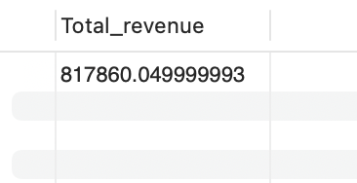

1. Average Order Value: The average amount spent per order, calculated by dividing the total revenue by the total number of orders.

USE pizza_store;

SELECT SUM(total_price)/COUNT(DISTINCT order_id) AS avg_order_value

FROM pizza_sales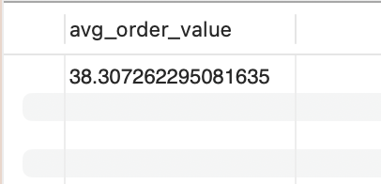

3. Total Pizzas Sold: The sum of the quantities of all pizzas sold.

USE pizza_store;

SELECT SUM(quantity) AS total_pizzas_sold

FROM pizza_sales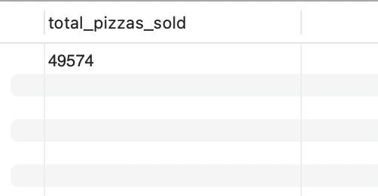

1. Total Orders: The total number of orders placed.

USE pizza_store;

SELECT COUNT(DISTINCT order_id) AS total_orders

FROM pizza_sales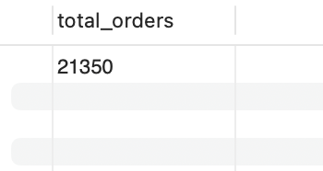

1. Average Pizzas Per Order: The average number of pizzas sold per order, calculated by dividing the total number of pizzas sold by the total number of orders.

USE pizza_store;

SELECT CAST(SUM(quantity)/COUNT(DISTINCT order_id) AS DECIMAL(10,2)) AS average_pizzas_per_order

FROM pizza_sales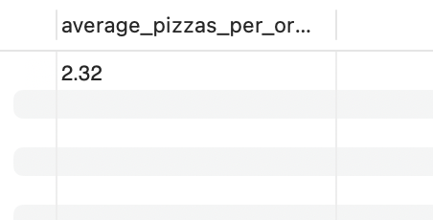

1. Daily Trend For Total Orders

***—MySQL—***

USE pizza_store;

SELECT WEEKDAY(order_date),

COUNT(DISTINCT order_id) AS total_orders

FROM pizza_sales

GROUP BY WEEKDAY(order_date)

ORDER BY WEEKDAY(order_date)

*Or*

USE pizza_store;

SELECT DAYNAME(order_date),

COUNT(DISTINCT order_id) AS total_orders

FROM pizza_sales

GROUP BY DAYNAME(order_date)

ORDER BY DAYNAME(order_date)

*—THERE IS AN ERROR IN THE DATA OF DATE COLUMN, I.E THE ORDER OF THE DATE IS FILLED IN WRONG MANNER AS SEEN IN THE IMAGE BELOW FOR MYSQL, BUT IT CAN BE DONE IN MS SQL—*

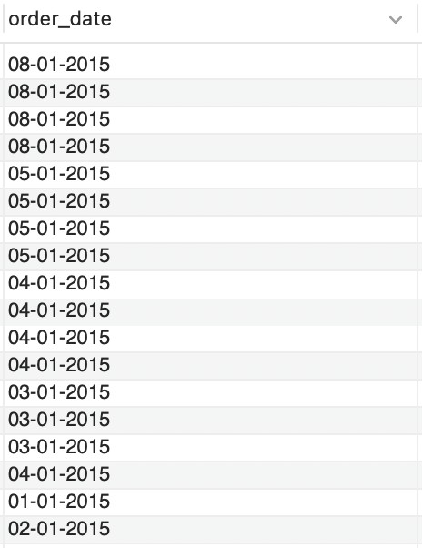

***—MS SQL—***

SELECT DATENAME(DW, order_date) AS order_day,

COUNT (DISTINCT order_id) AS total_orders

FROM pizza_sales

GROUP BY DATENAME(DW, order_date)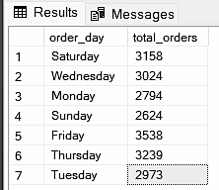

* 1. Percentage of Sales by Pizza Category

USE pizza_store;

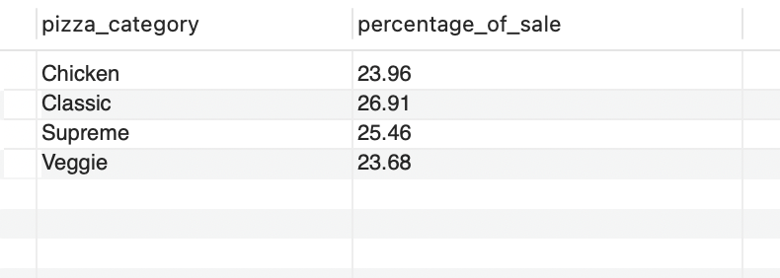SELECT pizza_category, CAST((SUM(total_price)*100/(SELECT SUM(total_price)

FROM pizza_sales)) AS DECIMAL (10,2)) AS percentage_of_sale

FROM pizza_sales

GROUP BY pizza_category

ORDER BY pizza_category

* 1. Percentage of Sales by Pizza Size

USE pizza_store;

SELECT pizza_size, CAST((SUM(total_price)*100/(SELECT SUM(total_price) FROM pizza_sales)) AS DECIMAL (10,2)) AS percentage_of_sale

FROM pizza_sales

GROUP BY pizza_size

ORDER BY pizza_size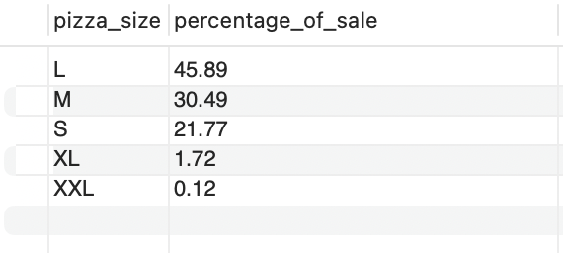

* 1. Total Pizzas Sales By Pizza Category

USE pizza_store;

SELECT pizza_category, SUM(quantity) AS total_quantity_sold

FROM pizza_sales

GROUP BY pizza_category

ORDER BY pizza_category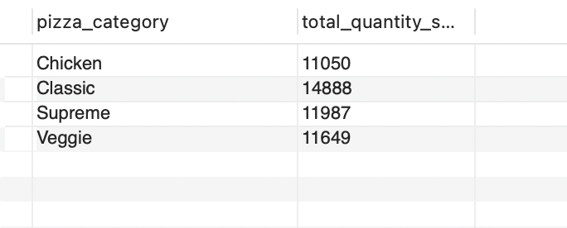

* 1. Total 5 Best Sellers By Total Pizzas Sold

USE pizza_store;

SELECT pizza_name, SUM(Quantity) AS total_pizzas_sold

FROM pizza_sales

GROUP BY pizza_name

ORDER BY total_pizzas_sold DESC

LIMIT 5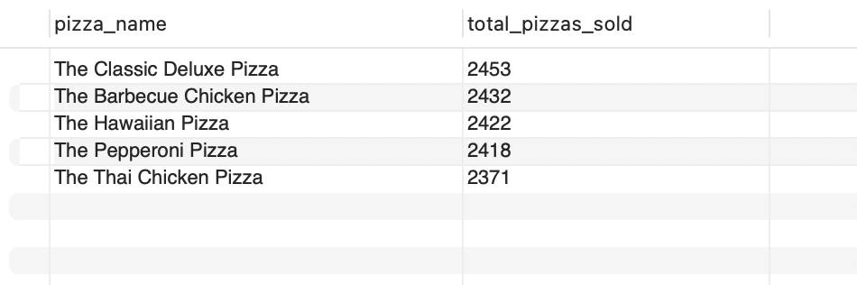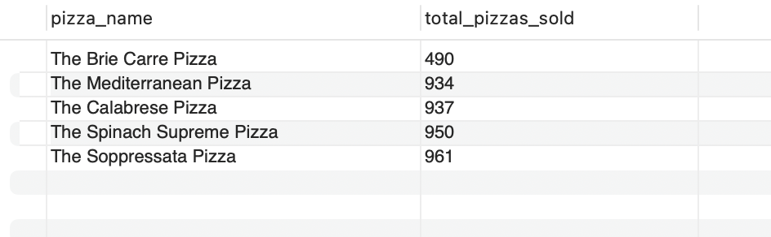

* 1. Bottom 5 Best Sellers by Total Pizzas Sold

USE pizza_store;

SELECT pizza_name, SUM(Quantity) AS total_pizzas_sold

FROM pizza_sales

GROUP BY pizza_name

ORDER BY total_pizzas_sold

LIMIT 5